MySavings Mastery Assignment
Reflection Log
Stefan S
CSE 3120 Object-Oriented Programming 1
(MySavings.java, PiggyBank.java)
How has your program changed from planning to coding to now? Explain.
This was the completed PiggyBank class:
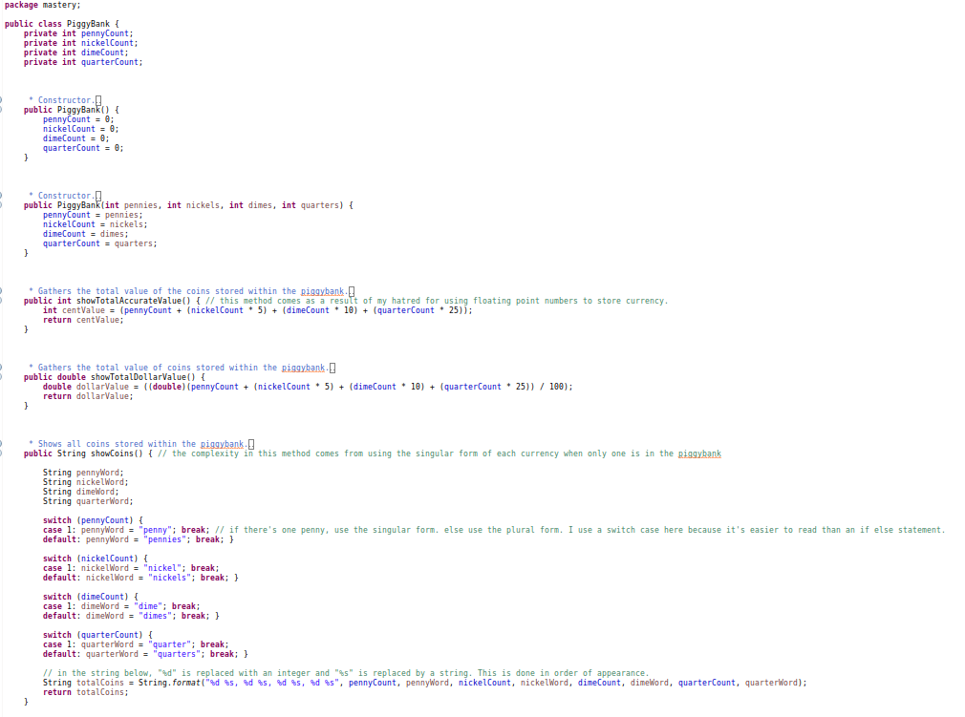
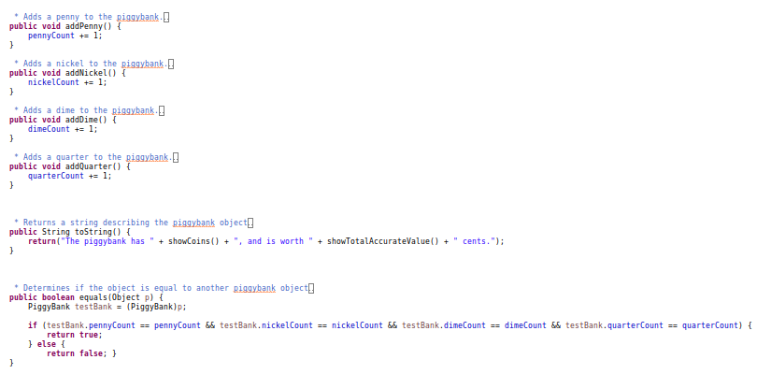

If I were building this class for use in the real word, I would spend more time adding some features. I’d overload the addPenny(), addNickel(), addDime(), and addQuarter() class to all pass integer values, which would then add an amount of coins respective to the value passed. I haven’t done this mostly just to save time, as they’re not needed for the MySavings program. equals() and toString() are also not needed, and nor are two different ways to get the total value, so I probably shouldn’t have spent my time on those either. They’d be trivial to implement if I ever needed them later.
The class did not deviate from my UML diagram.

